桃園市立武陵高級中學109 學年度上學期高三英文科第一次期中考試題
命題範圍：三民B5 L2,L3,L4, 妙妙卷第7、9回, English Digest 9月份, 7000單字Unit 8-12
第一部分選擇題：%
I. 聽力測驗：10% Part A: Pictures (3%)
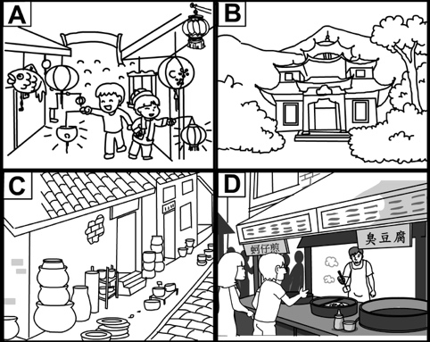 | 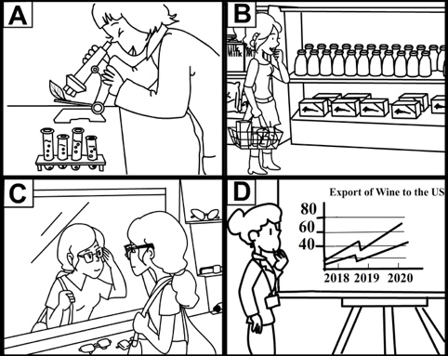 | 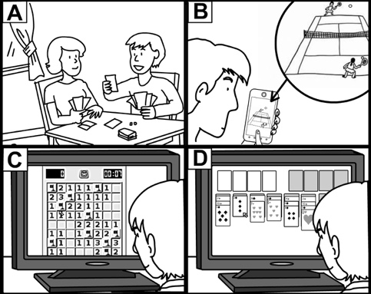
Part B: Best Response (2%)
4. | - We’ll find all kinds of Hakka-style foods there.  - It’s in the middle of a large forest.  - There are a lot of water activities we can try out.  - That street has new buildings made of steel and concrete. | 5. | - No, this project has turned out to be way too much work.  - Yes, your daughter was very well behaved while you were out!  - Absolutely! It was great to hear from a team of experts on this topic.  - Not really. Watching scary movies tends to stress me out.

Part C: Short Conversation (3%)
6. | - It was built in ancient times.  - It’s excellent and really worth seeing.  - It costs a lot of money to buy a ticket.  - It is known for its great seafood dishes. | 7. | - The speakers will be relatively early if they arrive at 8:30 p.m.  - The host will be angry if they’re not on time.  - The man thought the party would start at 9 p.m., but it won’t.  - Most of the guests will have already left by 9 p.m.
8. | - She can hear the same information that’s being signed.  - She is paying attention to the lecturer.  - She can read sign language fairly easily.  - She needs an interpreter to follow the lecture.

Part D: Short Talk Questions (2%)
9. | What is the purpose of this passage?  - To advertise for new staff at a coffee shop.  - To tell people how to make a great cup of coffee.  - To promote a coffee shop and its products.  - To give someone directions to a coffee shop. | 10. | Molly’s Café has a new drink. What flavor is it?  - Chocolate.  - Strawberry.  - Vanilla.  - Almond.
II. 單字：15%
- Can you telephone me ______ to arrange a meeting? I look forward to seeing you soon.
(A) in abundance (B) by comparison (C) regardless of time (D) at your convenience
- Closely bound to each other, the slowdown of the US economy occurred ______ with a downturn in Europe.
(A) inclusively (B) notably (C) extensively (D) simultaneously
- Due to the lockdown, Taiwanese people ______ to taking tours within the island this summer, for they are unable to travel abroad.
(A) resigned ourselves (B) had an addiction (C) deprived ourselves (D) plucked up the courage
- During the 75th U.N. General Assembly, Tuvalu Prime Minister openly praised Taiwan’s ______ towards collaborative global citizenship in the midst of the global fight against Covid-19.
(A) faculty (B) commitment (C) statistics (D) refreshments
- Even ______ by armed police, the extradition bill protesters in Hong Kong showed no intention of withdrawal.
(A) shunned (B) converted (C) confronted (D) dispensed
- Having a hard time achieving the weekly sales objective, Tina ______ her executive for assistance.
(A) inferred (B) conceived (C) consulted (D) justified
- In a television address, the UK Prime Minister called for the citizens’ solidarity after another ______ rise in Covid-19 infection during September.
(A) substantial (B) persuasive (C) memorable (D) productive
- It takes sheer ______ for Josh to devote himself to Artificial Intelligence for over 15 years before gaining significant progress.
(A) injection (B) monotony (C) temptation (D) perseverance
- The police announced that they would ______ a full investigation into the lead poisoning incident involving a traditional Chinese medicine clinic.
(A) undertake (B) disregard (C) sympathize (D) circulate
- Patients of the very clinic were anxiously waiting for the complete ______ report, fretting about being negatively affected by the prescribed medicine.
(A) grim (B) anxious (C) demanding (D) subsequent
- Some Filipino fishermen who suffered inhumane long working hours and excessive deductions from the salaries in Taiwan urged for their ______ to be seen as human trafficking.
(A) cabinet (B) outset (C) plight (D) intent
- The recently-passed national security law showed that the so-called "one country, two systems" model for both Hong Kong and Macau is not ______ in Taiwan.
(A) prior (B) feasible (C) vulnerable (D) specialized
- Tony gave me very ______ directions on how to find useful and reliable information online. Now I can keep on with my self-study project again.
(A) tough (B) explicit (C) terminal (D) mainstream
- When it comes to preparedness for earthquakes, a ______ element in surviving is how you react during the shaking.
(A) vulnerable (B) toxic (C) crucial (D) lofty
- When the trade war emerged between those two countries, the political leaders called on the citizens to ______ any product from the other country.
(A) administer (B) boycott (C) whistle (D) generate

III. 克漏字：40%
[A] In serious moments where public figures are making critical announcements, sometimes it’s not the public figure that people end up praising the most. Attention and admiration often __26__ sign language interpreters, who amaze people with their professional and quick translation skills.
Sign language interpreters help deaf and __27__ people see and understand spoken language, and their job demands great skills. First, a sign language interpreter must be fluent in both a local spoken and a local sign language. They also need an excellent memory so they can __28__ everything that’s being said.
One service sign language interpreters often provide in educational, commercial, and legal settings is interpreting over live video calls, called Video Relay Service. These fields require a thorough understanding of the subject matter, and the more technical the subject of conversation, __29__ the sign language interpreter will have to be in their translation. With all these demands, __30__ is no exaggeration to say that excelling in this challenging job is a sign of real genius.

26. (A) converts into (B) confines to (C) goes to (D) pick up
27. (A) impair-hearing (B) impairing-hearing (C) hearing-impairing (D) hearing-impaired
28. (A) adjust (B) reproduce (C) diminish (D) upgrade
29. (A) more creative (B) the more creative (C) more creatively (D) the more creatively
30. (A) which (B) what (C) this (D) it

[B] Mice’s reactions to stressful situations seem to be strongly influenced by their sex. Females are __31__ suffer from long-term stress disorders more often. The males, by contrast, show a greater ability to __32__ normal state after a period of high stress. The difference has to do with a stress hormone called CRF. This chemical causes elevated attention, __33__ the mouse __33__ danger. When the danger has passed, the brain no longer needs it. In male mice, the brain returns to its normal equilibrium relatively quickly, and the mice then calm down. __34__, female mice remain stressed for longer. Continued and excessive exposure to CRF causes long-term problems for the mouse, including mood disorders. It isn’t known whether the same process happens in humans. But it might explain why women are affected by mood disorders __35__ a higher rate than men.

31. (A) noticed to (B) responded to (C) ready to (D) destined to
32. (A) react to (B) look up to (C) hold on to (D) bounce back to
33. (A) equipping…with (B) leveling…with (C) preparing…for (D) campaigning…for
34. (A) Moreover (B) Still (C) However (D) Hence
35. (A) with (B) at (C) of (D) into
[C] Being a guest in someone else’s home is an opportunity to make a great impression. However, there
are certain dos and don'ts that are important to keep in mind when you __36__ someone a visit. Some of
these rules and guidelines vary a lot from one culture to another. __37__ them prevents you from unintentionally committing a faux pas. It also helps you __38__ as culturally literate and respectful.
One common __39__ of gratitude is to bring a gift for your host. Among adults, a bottle of wine is a
common choice. __40__ luxuries like nice chocolates or fruit are also wise choices. __41__ the gift is, the
intention should always be to present the host with a sign of appreciation.

36. (A) give (B) pay (C) show (D) provide
37. (A) Being in good hands of (B) Having a good handle on
(C) Turning your back on (D) Making a fuss of
38. (A) come off (B) socialize with (C) figure out (D) break away
39. (A) sign (B) gesture (C) position (D) idea
40. (A) Another (B) Others (C) Other (D) While
41. (A) Whichever (B) However (C) Whoever (D) Whatever

[D] Parasite is a thrilling, tense comedic drama that explores themes of economic inequality and the stratification of society. In a bid to escape crushing poverty, a poor family attempts to __42__ itself to a richer one, securing jobs in their household such as driver and housekeeper. However, their __43__ to improve their economic status runs into trouble. The lies they’ve been telling __44__ a dark secret lurking below the surface in the seemingly perfect home. The brilliantly written and expertly told story was a hit around the world, winning fans __45__.

42. (A) attract (B) attack (C) attach (D) attribute
43. (A) effort (B) identity (C) statistics (D) consequence
44. (A) transfer into (B) collide with (C) tend to (D) see through
45. (A) in and out (B) to and fro (C) far and wide (D) now and then

[E] At the age of nine, I was sent out of my war-ravaged homeland, Greece, and came to live with my father in America. When __46__ to choose a hobby to pursue during club hours, I decided to follow the prettiest girl in my class. This decision led me to the writing club, __47__ the instructor, Miss Hurd, later became my mentor. One day, she made us compose an essay from our own experience. Fixing me with a(n) __48__ look, she asked me to write about what had happened to my family in Greece. The memories were so painful that I put the assignment off __49__ the last moment. Reluctantly, I started to write, line after line, __50__ how the enemies had occupied our village and how my mother failed to make an escape. __51__, Miss Hurd sent my essay to a contest and it won me a medal. My father and the Greek community were full of pride. For the first time, I realized the power of the __52__. Later on I studied journalism, became a reporter, and __53__ my mother’s story published. I was lucky enough to have met Miss Hurd, who had directed my grief and pain __54__ writing. Miss Hurd was undoubtedly the catalyst that caused all the good things in my life, but she would probably deny any of __55__.

46. (A) asked (B) asking (C) to ask (D) ask
47. (A) which (B) where (C) that (D) when
48. (A) emphatic (B) vivid (C) stern (D) solitary
49. (A) in (B) at (C) since (D) until
50. (A) as describe (B) describing (C) described (D) after describing
51. (A) With a relief (B) For the better (C) As follows (D) To my surprise
52. (A) literary world (B) grammatical award (C) written word (D) arms contest
53. (A) had (B) having (C) to have (D) having had
54. (A) into (B) with (C) on (D) for
55. (A) these (B) theirs (C) those (D) that

[F] Music, worth the name of the most universal language, has the supremacy everywhere, from bombarded ruins to stunning concert hall. In the war-torn Sarajevo in 1992, __56__ occurred a brutal shelling, which took 22 innocent civilians’ lives on the spot. __57__ the massacre put Smailovic, a cellist living in the neighborhood, past his capacity to endure. He resolved to defy the war with music. For the following 22 days __58__, this cellist played anguished and haunting pieces next to the craters, letting his moving melody __59__ in the air, __59__ the survivors, and __59__ a glimmer in the darkness. Though the shelling went on, Smailovic rode out the attacks.
Smailovic’s courageous deed struck a sympathetic chord among the suffering people as well as the music circle worldwide. An English composer was so moved that he wrote a composition for unaccompanied cello, __60__ he poured rage, love, and brotherhood with Smailovic. This piece was later selected and played by the world-famous cellist, Yo­Yo Ma, on the opening night of the International Cello Festival. At the end of Ma’s flawless performance, a mysterious guest __61__ the audience silent. It was Vedran Smailovic __62__ was invited to the venue! Upon realizing this, the audience filled the hall with deafening applause and cheering. Their arms __63__ around each other, these two cellists were soaked with tears. One was an elegant prince of classical music; the other, dressed in a tattered leather jacket, __64__ wrinkled face framed by wild hair and mustache. __65__ the former __65__ the latter, the performers or spectators, the battlefield or the music hall, they were all stripped down to the deepest humanity in the face of music. Such strong compassion clearly illustrates that the power of music can never be overstated.
56. (A) one open bakery (B) opening a bakery
(C) where a bakery opened (D) right outside one open bakery
57. (A) Witness (B) Witnessed (C) Witnessing (D) To witness
58. (A) at an end (B) in a row (C) in turn (D) on purpose
59. (A) flow; soothe; add (B) to flow; to soothe; to add
(C) flowing; soothing; adding (D) flowed; soothed; added
60. (A) where (B) into which (C) that (D) what
61. (A) left (B) stayed (C) caused (D) considered
62. (A) whom (B) when (C) why (D) that
63. (A) thrown (B) threw (C) throw (D) throwing
64. (A) of which (B) with (C) had a (D) whose
65. (A) Neither; or (B) Whether; or (C) No matter; how (D) Both; and

IV. 文意選填：15%
[A]
- ethical | - prohibit…from | - ambushed | - entitled
- disobedient | AB. smuggled | AC. identify…with | AD. appreciate
Wildlife attractions, particularly those involving elephants, play an important role in Southeast Asia’s tourism industry. Many elephant camps give visitors the chance to __66__ these magnificent animals up close. However, the elephants are often treated badly at these locations.
The problem starts with how the camps get hold of the elephants. While some are bred in captivity, others are __67__ and captured in the wild. What’s more, elephants are __68__ around the region with the assistance of government corruption. Things get worse for the elephants at the camps. They are put through brutal training regimes to ensure that they stay in control without __69__ behaviors.
There is an increasing number of elephant sanctuaries for abused or elderly elephants, which outwardly seem __70__. But they are not doing better. People visiting these places are able to feed and bathe the elephants, and this involves behind-the-scenes control. In addition, the elephants still behave in a way that they wouldn’t in the wild, such as taking multiple, lengthy baths a day.
Elephant sanctuaries with decent welfare conditions __71__ visitors __71__ direct contact with the elephants. That is, elephants are allowed to express their natural behaviors. To show genuine love for these beautiful creatures, we should make sure elephants get the care they are __72__ to as best as we can.

[B]
- artificially | - slaughter-free | - eco-friendly | - substitutes
- harmful | AB. constantly | AC. encouraging | AD. expectations
Will you eat a hamburger if you know it doesn’t come from a real cow? The question isn’t about vegetarian __73__ for meat. Rather, it’s about a technology that sounds like science fiction but has already become laboratory reality: real meat, grown __74__.
Experts are now capable of taking a sample of a single cell from a living animal and __75__ it to divide. The result of this process is actual meat, but an animal didn’t need to die to provide it. Using this technology, you can eat chicken nuggets that taste just like the ones at McDonald’s, while the chicken it came from is still happily pecking at seeds.
Scientists’ motivation for developing lab meat isn’t just to give meat consumers a __76__ way to satisfy their hunger. They’re also driven by the need to give people less-polluting alternatives to regular meat. Large-scale meat production is notoriously __77__ to the environment. Industrial fishing depletes the ocean’s schools of fish; cattle farmers are __78__ cutting down forests to clear land to raise livestock; even chickens, which are a relatively __79__ animal to have, require plenty of space and resources. If lab meat can be produced in the right amount, it could meet our __80__ without consuming too many of Earth’s precious resources.

第二部分非選擇題：20%
I. 單字：15%
1. Max works on a e days this week, which means he works on Monday, Wednesday, and Friday.
2. Rick was petrified with fear when he saw a dog baring its teeth and g ling at him.
3. The veteran actor Yu An-shun took home the Best Leading Actor in the 55th Golden Bell Awards with his d hed performance in a mini-series TV movie, “Lucky Draw(做工的人).”
4. The government imposed a maximum p y of a fine of NT$15000 for refusing to wear face masks on
transport.
5. A philanthropist donated money to f e the construction of the new library in the city.
6. After several years of hard work and investment, Tommy has a ed a great deal of wealth.
7. Before meeting her life-changing teacher, my sister was a r s, trouble-making girl who was difficult
to control.
8. If the all opposition group u e, they may be able to command over 55 percent of the vote.
9. Seeking to define justice, the philosophy professor challenged his students to look at some social,
economic, and political issues with different p es.
10. Different religions or cultures have varying mourning and burial r ls.
11. As Anna approached the haunted house, she heard some w d noises coming from the building.
12. The government has enforced some entry r ns for people arriving in Taiwan in response to
COVID-19 outbreak.
13. The remote town has been completely a ned after heavily damaged by a mega-earthquake. There is
no residents at all now.
14. The most urgent mission for the government is to s ze the economy after the financial crisis.

II. 翻譯：6%
1. 要不是我當時的粗心，我可以高分通過考試。3%
Had (2%) my carelessness, I could (1%) the test with flying colors.
2. 想得到升遷的想法激勵Bryan拼命工作。3%
The thought of getting promoted s red (1%) Bryan to off.(2%)

